Community Partner name: Saskatoon Poverty Reduction Partnership (SPRP)
Conversation date: December 9, 2021

1. Introduction

A. Summary

The conversation about the intersection between poverty, income and climate is a new one for the partners at the SPRP. That being said, the 12 Bold Ideas to Eliminate Poverty reflects on specific aspects of climate action within sectors (including housing, transportation, income and food security). Moving forward, the results of this consultation indicate that there is room to deepen the understanding of and commitment to climate action in the strategy work of the SPRP. This conversation will continue as the partners operationalize the strategy to eliminate poverty. Particular areas of concern are the growing homelessness/housing crisis in Saskatoon, strategies to improve food security and localized access to food, infrastructure connections with the City of Saskatoon (transit, library, festival sites) and a growing commitment to implement a guaranteed basic income in Saskatchewan.
B. About the Green Resilience Project
This community conversation was part of the Green Resilience Project, a Canada-wide series of conversations exploring and documenting the links between community resilience, income security and the shift to a low-carbon economy. Working with a designated partner organization from each community, the Green Resilience Project created space for a wide range of participants to talk through the links between climate change and income security and identify possible next steps to build or maintain community resilience in the face of these challenges.

This Community Summary Report reflects what we heard and learned in our community’s conversation. Each Project partner organization across Canada will be producing a similar report. In March 2022, the Green Resilience Project will produce a final report summarizing findings across conversations, which will be available to the public and shared with Environment and Climate Change Canada.

Funding for the Green Resilience Project is generously provided by Environment and Climate Change Canada’s Climate Action and Awareness Fund. The project is managed and delivered by Energy Mix Productions, Basic Income Canada Network, Coalition Canada Basic Income - Revenu de base, Basic Income Canada Youth Network, national experts and local partners
C. About the Community Partner organization
The Saskatoon Poverty Reduction Partnership (SPRP) collaborates with community partners from across sectors, demographics and experiences, working in Saskatoon, Saskatchewan. Saskatoon (ᒥᓵᐢᑲᐧᑑᒥᓂᕁ misâskwatôminihk) is a city with rich histories. It is located on the South Saskatchewan River on Treaty 6 Territory and the Homeland of the Métis. We acknowledge the people of Nêhiyawak, Dakota and the Round Prairie Métis, who played a crucial role in establishing what we now call Saskatoon. We respect our ancestors and cherish our relationship with one another as we work together on a journey to end poverty in Saskatoon.

The SPRP was established in 2009 through a community charette that identified a need to work collectively on social determinants of health driving cycles of poverty and inequity in the community. Over the last 13 years, the SPRP has adopted a collective impact model with constellation governance focusing on the intersectoral and multijurisdictional interface between human service policy and practice.

In 2021, the SPRP relaunched the 12 Bold Ideas to Eliminate Poverty with a “lessons learned during COVID” focus. The over 100+ partners across many sectors are focused on operationalizing this work through 4 core mechanisms: catalyze, convene, coordinate and collaborate using the foundational priorities: Nothing about us, without us; We are all Treaty People; and We are a city that bridges.

While the 12 Bold Ideas to Eliminate Poverty does not have a climate-specific focus, many of these ideas are deeply rooted in environment and climate, noting that residents facing inequities are often profoundly impacted by climate and environmental pressures. When the opportunity to host this dialogue was presented, the SPRP partners were eager to add climate change and environmental policy/practice to the conversation about eliminating poverty in Saskatoon and how the policies/practices to address climate change intersect with the current 12 Bold Ideas to eliminate poverty.
- The preCOVID 12 Bold Ideas can be found here: SPRP12BoldIdeasToEliminatePoverty.pdf (communityview.ca)
- The relaunch with the COVID lessons can be found here: SPRP 12 Bold Ideas Lessons Learned During COVID19.pdf

D. Why this community was selected to have a conversation
The facilitators focused on situational awareness for current income pressures, food security, housing and climate for this conversation. Additional inequity data can be found in the 12 Bold Ideas to Eliminate Poverty.

Income (and Assets): The SPRP definition
Income/assets are monetary and non-monetary things that people accumulate to participate in their community fully. Income can come from various sources, including employment and assistance programs. Assets can be monetary (like savings, insurance and investments) but more often are non-monetary and consist of objects like a house, car, or other possessions. These can include other safety-net-based items such as identification and access to family, friends and other supports.

What we currently know about income in Saskatoon includes a closer look at the relationship between low-income sources and the Market Basket Measure (MBM)/Canada’s official poverty line and the Living Wage.

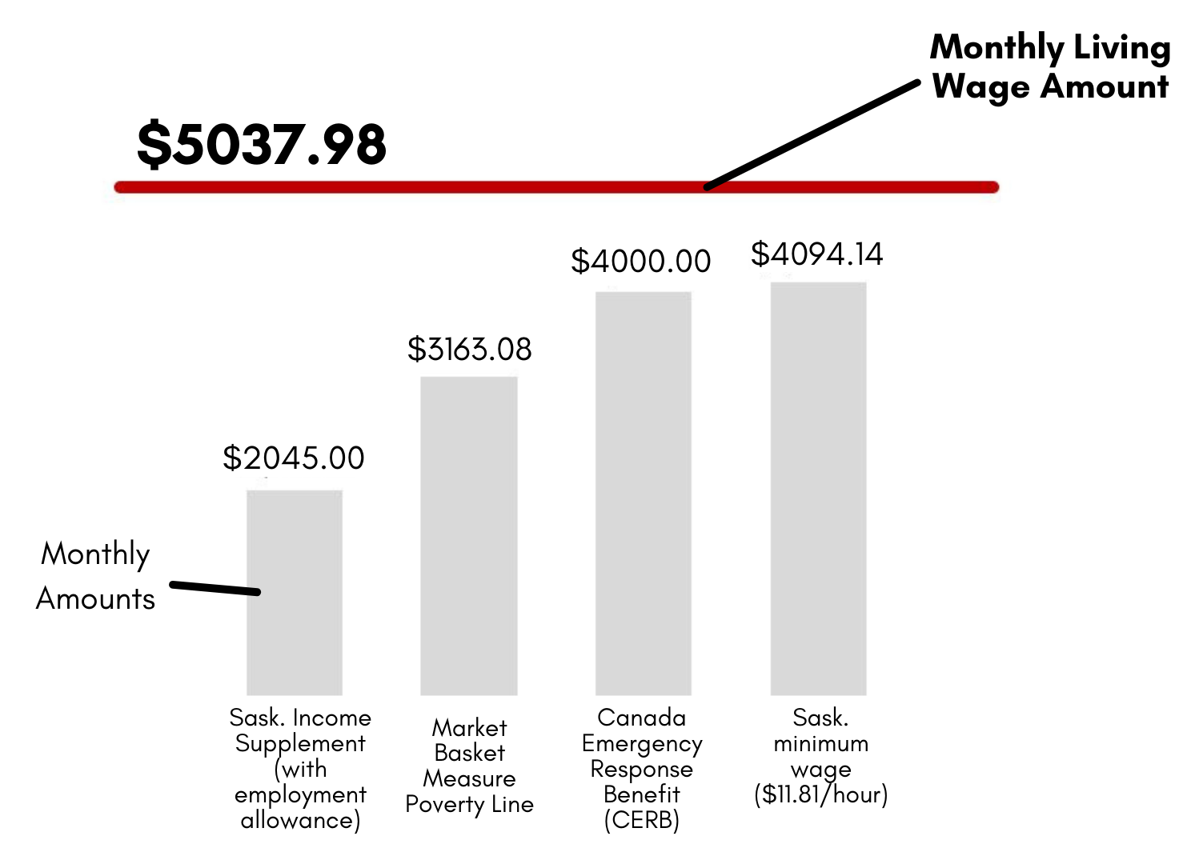
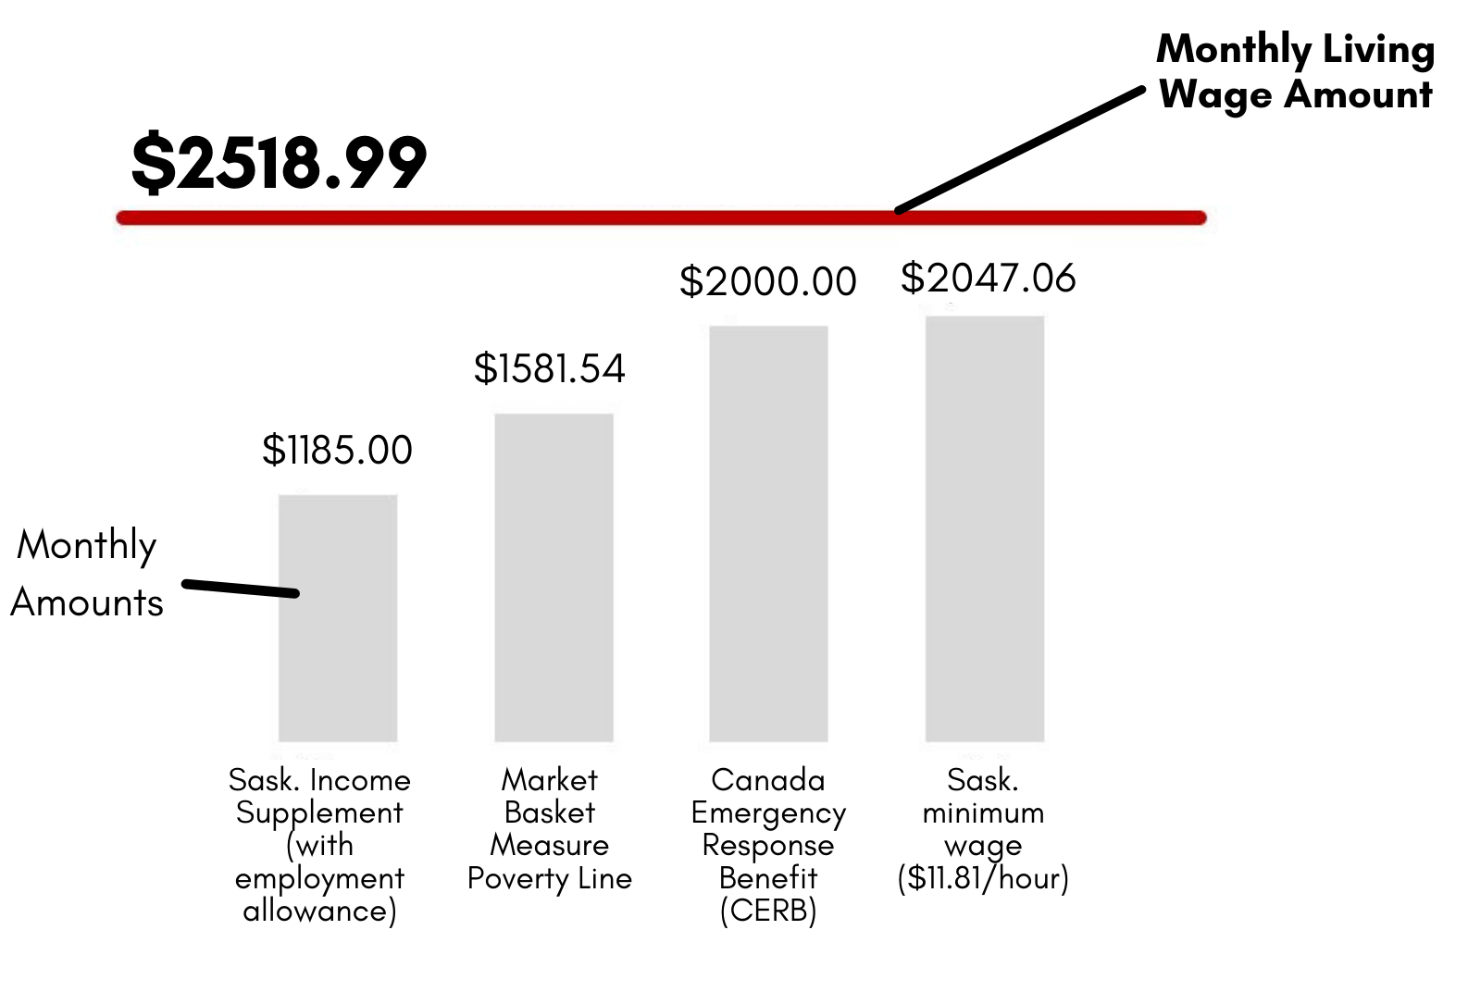

Figure 1: Comparison of income levels - using the Living Wage as a benchmark best practice

Other Poverty sectors to consider:
While we spent a great deal of time covering the current income landscape and talking about basic income policy, there are other factors to consider. The SPRP would highlight that there are 12 Bold ideas to consider. For the sake of time, the participants took a deeper look at the interconnectedness of housing/homelessness, food insecurity and climate.

What is food security: Food security is a complex issue, and there are many factors which affect whether a person is food insecure, such as the availability of food that is healthy, nutritious and culturally appropriate, and the financial and physical access to food.

Taking a look at local context data around food security, we know the following things are true:
- Almost 50% of the monthly users of the Saskatoon Food Bank & Learning Centre are children
- In 2020, The Saskatoon Food Bank & Learning Centre distributed 49,482 Emergency Food Hampers provided to the community totalling 737,997 lbs
- 50,337 L of fresh milk provided through the Saskatoon Food Bank & Learning Centre Milk For Children Program

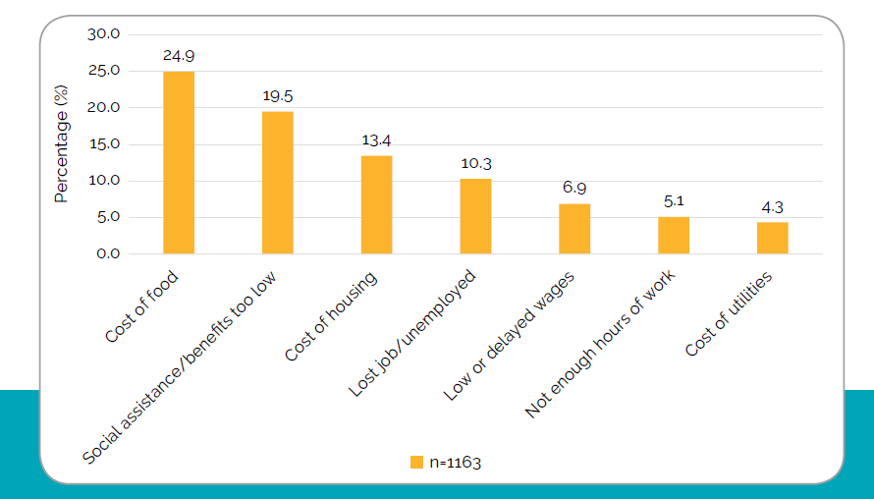

Also, looking at the most recent Hunger Count, it’s important to note where people prioritize the spending of limited resources and the reasons they provide for not prioritizing food.

Figure 2: Spending Categories
How is food tightly connected to climate?
Climate change will affect all four dimensions of food security (FAO, 2006):
- food availability
- food accessibility
- food utilization
- food systems stability.

Extreme weather patterns may impact agriculture conditions. Extreme heat and excessive rains will make growing conditions challenging in places. These weather patterns will mean that regularly available food will become unpredictable. Alternatively, some northern geographic areas may see extended growing seasons. With the increased risk to farmers, prices will rise as crop insurance rises, making food less accessible to more people. There are non-food inputs such as clean water and health care that increase food utilization. Both availability and access rely on a stable food system that is resilient against sudden shocks.

People who are already vulnerable and food insecure are likely to be the first impacted in conditions of food systems instability. As an indirect effect, low-income people everywhere, particularly in urban areas, will be at risk of food insecurity due to loss of assets and lack of adequate insurance coverage.

Housing and homelessness: During this section, participants discussed the costs of housing, the lack of affordable stock, limitations on improvements for efficiency or “green retrofitting” (even for people who would be able to navigate the system, affordability becomes a tremendous barrier).

In Saskatoon, we know the following things:
- Point in time homelessness count (2018) indicates that there are nearly 500 people who self identify as homeless
  - 85% are Indigenous
  - 5% are youth
  - 65% have had connections to the child welfare system
- The Median Multiple (ratio between median house price and gross annual household income before tax) in Saskatoon is 4.2 (under 3.0 is affordable)

As a final thought, we challenged the participants to consider other sectors outlined in the 12 Bold Ideas and provided additional examples that included:
- Transportation (public transit but also how people move around the city and through the province)
- Health (how climate action is connected to health equity)
- Lessons learned during COVID

Climate and Poverty: Within Canada and worldwide, the poorest people are often most drastically impacted. Wealthier nations and families have more power to cope with the impacts of climate change:
- Higher incomes allow people to afford air conditioning, cottages, travel, energy and energy-efficient homes, electric cars, landscaping and water features
- Higher incomes allow people to live in safer places, away from swelling rivers and tinder-dry wooded areas, and the capacity to have insurance
- Privilege fills grocery carts, even as food prices soar
- Wealth and affluence creates opportunities to move if need be

Families in low-income countries are often the least involved in human-made climate change. Yet they typically bear the worst of the impact.

Climate change can increase the numbers of people living in poverty and deepen the context of that poverty, particularly in a province that relies on resource extraction with a large portion of the economy in agriculture without provincial support to increase sustainable initiatives.

What do we know about climate change in Saskatoon? https://bit.ly/3ulBYFE
https://www.saskatoon.ca/sites/default/files/documents/climate_action_plan-final-web-print.pdf

Under the current modelling, we are likely to see the following weather patterns:
- 24% increase in winter precipitation
- More than 30% increase in spring precipitation under status quo emissions rates
- Warmer winter days = increasing amounts of freezing rain
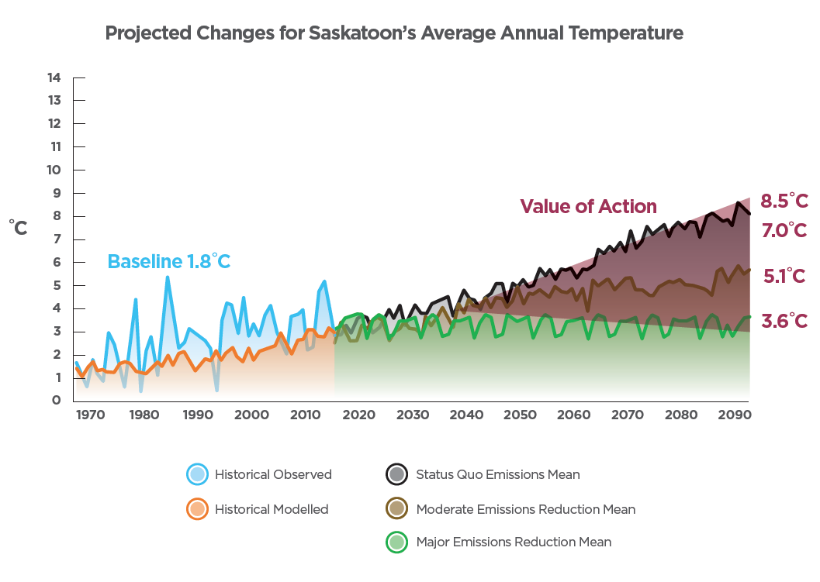
- Seasonal wind speeds are increasing in winter and spring and decreasing in the summer and fall

Figure 3: Projected Changes for Saskatoon’s Annual Average Temperature

During the presentation, participants had an opportunity to consider the projected changes for Saskatoon’s avg annual temperature. We also addressed the pressures we are faced with - and how visualizing data like this can cause climate anxiety.

In Canada and Saskatchewan specifically, we have already experienced extreme weather events over the past 20 years. We will expect to see more weather events if changes are not made to climate policies and practices.
- Drought - 2001-2002 reduced ag production costing $1.6 billion
- Wildfire - 2015 destroyed over 1.7 million hectares forcing 10,000 people to evacuate and cost more than $100 million
- Flooding - 2014 severe flooding in southeastern SK

Extreme weather events (or natural hazards) such as drought, wildfire, and flooding are part of Saskatchewan’s history and have significant economic repercussions for the region. The 2001- 2002 drought caused a reduction in agricultural production of more than $1.6 billion. The forest fires in Saskatchewan in 2015 cost over $100 million, destroyed over 1.7 million hectares and forced more than 10,000 people to evacuate their homes in northern communities. When the economy suffers, governments tend to increase austerity measures that are particularly difficult for people with lower incomes.
E. About the conversation participants and Demographics
The invitation to attend the event was shared with many collaborative community-driven teams in Saskatoon. The SPRP leadership team is represented by more than 100 partners across intersectoral and multijurisdictional sectors. In addition to inviting this team, we invited members of the Saskatoon Interagency Response, City of Saskatoon staff, and community partners with lived experience of poverty.

During the initial planning of the event, the following sectors were identified and targeted as critical to include: SPRP partners, Agencies serving vulnerable populations, City of Saskatoon (staff, admin and elected officials), SK environmental/climate groups, CUISR (Community-University Institute for Social Research), basic income advocates, partners with lived/living experience, newcomers, Indigenous people, youth and business leaders.
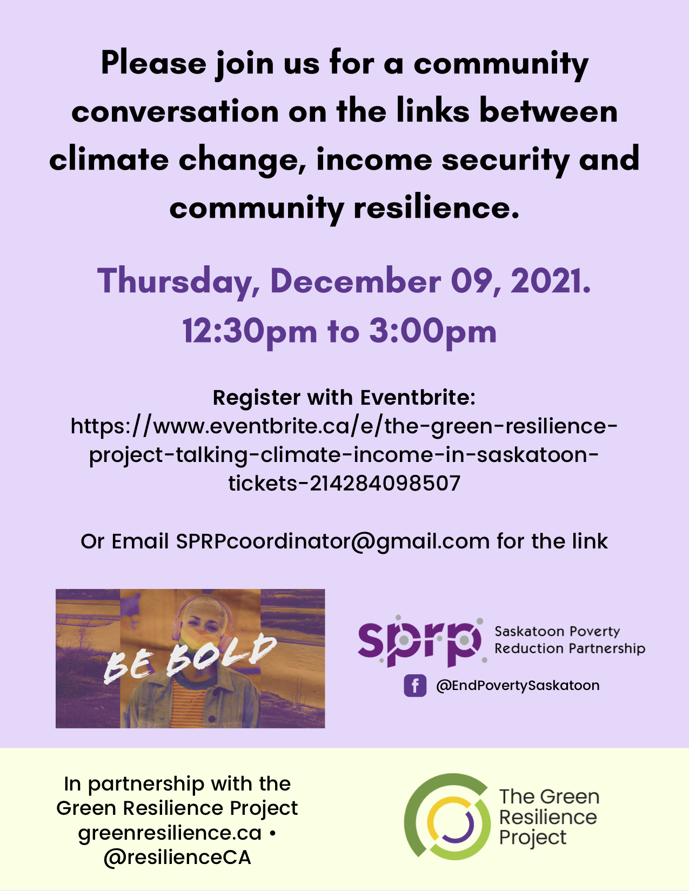
The SPRP and community partners shared the invitation on social media platforms, through email, and personal invitations to participants. Here is a sample poster:
Figure 4: Event Poster

Here is a link to the SPRP FB post:
Facebook

Only ten people completed the intake form. No one identified as Indigenous or a person of colour or recent immigrant; one identified at 2SLGBTQ+; one with disability

Table 1: Demographics of participants
Characteristic | Number |  | Characteristic | Number
Age 20-40 | 5 |  | Non-profit, charitable or grassroots organizing work | 5
Age 41-60 | 3 |  | Health sector | 2
Age Over 60 | 2 |  | Education sector | 4
Men | 2 |  | Government services | 1
Women | 8 |  | union yes | 6
High income | 3 |  | union no | 4
Middle income | 5
Low income | 1

Twenty-four participants registered using the Eventbrite link, including the ten who completed the intake form. Of these participants, three people self-identified as SPRP community partners living with experience of poverty. All SPRP partners with lived experience were compensated financially for their participation in events. Two of these participants were First Nation or Metis.

As a next step - the SPRP will be hosting a survey to deepen the connection to key stakeholders and work to operationalize the recommendations and commitments identified in this preliminary consultation.

F. The Community Conversation

This conversation was held using Zoom on December 09, 2021, from 12:30 pm to 3:00 pm in Saskatoon, Treaty 6 Territory and the Traditional Homeland of the Metis.

The following ppt was used to structure the conversation: Green Resilience.pptx

The agenda included: introductions and overview of the project, situational context about the intersection of poverty, climate, and income in the community (and to some extent across the province). Upon completion of the background and context, the participants were divided into breakout rooms to address four questions, including time to come together to discuss the breakout dialogues.

The following four questions were asked:
- How are the changes to our community’s environment and economy affecting you, your family or the community as a whole?
- We’re here today to talk about how climate change and income security are connected to each other and to our community’s resilience. How are these environmental and economic changes related to each other?
- What are some possible solutions to the challenges we’ve discussed that will help the community respond to climate change and create income security for all community members?
- Now that we’ve talked about some solutions, how do you think these solutions can be achieved to build, maintain or strengthen community resilience? Who is responsible for these changes—individuals, community groups, governments or a mix?

The facilitator team viewed the format and overall outcome as successful given the time of year and the community’s COVID-related pressures.

2. What We Heard

A. How are the changes to our community’s environment and economy discussed in the introduction affecting you, your family or the community as a whole?

Overall, three main themes emerged from our conversations on this first question: 1) increasing food insecurity and costs to eat; 2) affordability of housing and remedying increasingly hot or cold weather; and 3) anxiety about extreme climate events. It should be noted that discussion participants generally described that all three of these issues could negatively affect the health of any given individual.

To begin, many participants described both personal and professional examples of how climate change is driving food insecurity in Saskatoon. This food insecurity is driven by increased costs or inflation of essential foods (e.g., bread, dairy). Considering that this organization’s clients had fixed incomes that show no signs of increasing, many discussion participants concluded that those with low or fixed incomes would have to pay the costs of climate change-driven food insecurity, not the food suppliers.

“Through work here at CHEP, we are seeing the effects of inflation. We try to offer the community food at the lowest possible price by purchasing through a wholesaler (for example, our dairy wholesaler has already said that prices will increase by 13% in January 2022), but with prices rising in the new year, we may have to increase prices we sell foods at which is not our goal - considering many people who use our services are on a fixed income that hasn't changed.”

Furthermore, other participants described how the effects of extreme weather events in Saskatchewan (namely heat waves and periods of extreme cold) cost more to avoid. Similar to the cost of food, this is becoming increasingly difficult for the most vulnerable living in Saskatoon. For example, housing that is climate-change resistant is difficult to afford (e.g., a residence with air conditioning, good insulation, weather-proof windows, an efficient furnace, etc.). This means housing is either costing more or entirely unrealistic to avoid the effects of extreme weather events for some in Saskatoon. In other words, only the most affluent citizens in Saskatoon can realistically afford to try to avoid the consequences of climate change.

Perhaps predictably, these two discussion points appear to be driving a third main point emerging from this question: anxiety regarding the effects of climate change and the next generation’s future in Saskatoon. Namely, participants described being worried about the costs of living in Saskatoon for their children due to increasing climate-change demands, feeling vulnerable about living in Saskatoon (including a feeling of uncertainty of what Saskatoon will look like for future generations), and uncertainty about what a given individual or organization can realistically do to reduce their footprint without significant government help. Particularly striking about this discussion was that this increased anxiety appears to be felt by all Saskatoon citizens, not just the most vulnerable like the previous two themes.

B. How are these environmental and economic changes related to each other?

Discussion groups were aware climate issues are symptomatic of societal issues with power imbalances in society. Poverty was seen as a result of current societal policies and exacerbates harm to the environment. The need for inexpensive goods drives the production of disposable goods creating harm to the environment. Comments were made that people were raised within the current system, and it is hard to change actions without a vision of a different way of living.

“Oil field people defend their place in the work, and they are expressing fear and have set
themselves up in a lifestyle that is unsustainable.”

Many stated that the power currently is in the hands of institutions as well as people who have higher incomes. Businesses and institutions were seen as having the power to look deeply at their practices to reduce poverty and climate impact.

The current societal structure has diminished the voice of Indigenous peoples and the traditional knowledge and value of caretaking the land. Indigenous peoples' historical and current oppression is another example of how poverty and climate impact intersect. Participants suggested looking at knowledge of Indigenous peoples and other silenced voices.

Food insecurity was also seen as a symptom of current policies and a place where climate change and income intersect. Along with the food system, there is poverty (i.e. migrant workers) and climate harm (huge food transportation costs).

C. What are some possible solutions to the challenges we’ve discussed that will help the community respond to climate change and create income security for all community members?

Remember to question whose voice is being heard. What story is being told from what perspective? Mindful engagement is essential, and having different voices and different values involved in conversation and action will be necessary.

Recognize the true costs of the developed world lifestyle through an invoice from Mother Earth. Accounting for the cost of resource extraction needs to be part of the answer. We all need to be accountable and understand the public and private benefits of consumerism and monitor the effect. Similarly, there needs to be a clearer understanding of where tax dollars go and that nothing is “free.” We can shift the value of taxes understanding that life is easier when you invest in things that make life better for more people.

“It’s easy to look at the best practices from other countries - the hard part comes from
understanding the way they embed climate action and accountability into their taxation
policies”

Social Return on Investment (SROI) for a Basic Income Guarantee (BIG) program –understanding the downstream benefits of BIG. The basis of SROI is understanding the social benefits and using a proxy value to provide a ratio indicating the financial investment and return of a program. SROI can capture elements such as the peace of mind for people who are otherwise unsure if they will have the next paycheque and understanding what that means - trying to monetize the potential benefit of unconditional income security. BIG would be a solution to income insecurity regardless of the impacts of climate change.

“There is a misconception that it (BIG) will create a generation of lazy people, but no
research shows this.”

“We live in a province that responds to the economic arguments of things - we should create better understanding of the relationship between income, poverty and climate using an economic lens”.

It is vital to encourage a more local food system, recognizing growing food costs and potential instability of the food system. A local food system helps with a variety of concerns, including climate change mitigation by reducing the added effects of transportation (reducing the distance for food to travel). A localized food system also allows communities to rely more on local providers when climate crises like the BC floods and fires occur. There are also local economic benefits with a local food system. Furthermore, there is a need to strengthen the local meat industry and general food processing at the local level. It will be important to strengthen food literacy, including the history of food in the area, and work with people to grow, process and cook local and economical food.

“Encouraging a more local food system - helps with a variety of things including climate change mitigation without the added effects of transportation (or as far). Also allows us to rely more on local foods for food security when climate crisis' like the BC floods and fires occur, and of course has local economic benefits.”
Improving internet connectivity can help with reducing the need to travel.
“Zoom is important to keep us from needing to travel so much”
“Saskatoon needs a free to use wifi system”
There needs to be a stronger emphasis on the right to life including “renting housing justice” and enforceable standards for heating and cooling. For example, if it is unsafe to have the windows open, then passive cooling is impossible. Landlords need to be accountable for providing homes that are sufficiently temperature controlled. While standards are often set for heating in the winter, there are insufficient guidelines for cooling in the summer. If there are bylaws or regulations for adequate housing in place, then there also needs to be access to justice and support to push for enforcement. Governments could divert taxes to expand public housing supply, ensuring people have sufficient housing at appropriate standards.

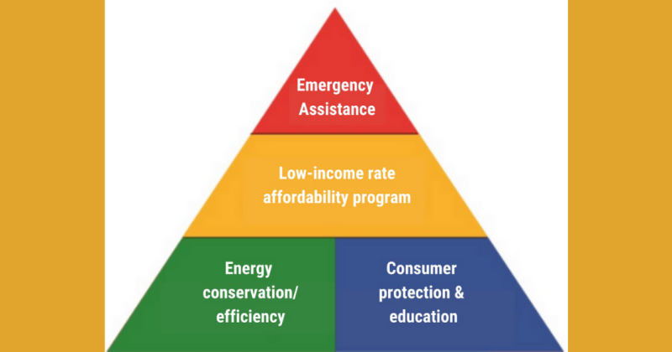

Figure 5: Canadian Environmental Law Association https://cela.ca/working-paper-energy-justice-poverty-a-case-study-for-ontario/

One participant noted the importance of implementing the energy poverty pyramid (see Figure 5), ensuring emergency protections, affordable rates, valuing renters by investing in utility bill protections to keep citizens alive, healthy and productive. There needs to be a plan for blackouts and medical gear requiring energy inputs. Understanding that energy conservation is not the primary objective for housing is essential.

There needs to be greater government involvement with grassroots organizations in addressing the challenges ahead. As one person said:

“Been in many meetings like this, but I have yet to be in any meeting with a government
official attending. How do we convince the powers that be that the money needs to be spent now?”

The City of Saskatoon has been leading the province, and while much of the action occurs at the local level, provincial and federal budgets guide what shapes society on a more significant level.

“Understanding which government level holds which levers will be important for advocacy”.

D. How do you think these solutions can be achieved to build, maintain or strengthen community resilience? Who is responsible for these changes—individuals, community groups, governments or a mix?

The breakout conversations focused on how all people should be considering their role in climate action at every opportunity. While individual impacts may appear minimal, there was a consensus that working collectively would have dramatic impacts over time.

Participants considered other social movements and how they took hold. Connecting to younger generations and building capacity for the expectation of climate action will prove to be a good motivator for public policy changes.

“If we consider how reduce, reuse, recycle was implemented - there were resources
connected to the Education system - much of the “political will” comes from middle class
parents being pressured by their children to make changes”

While it is almost too easy to say “everyone is responsible,” participants identified specific connections to government, non-profit, community agencies and individuals. Living in a province with considerable conservative leadership and a deep-rooted affair with fossil fuels was identified as highly problematic but not impossible. Working with allies at other government levels, such as municipalities and Indigenous governments, could create relationships with provincial leadership and open avenues for dialogue about climate action in public policy.

“This is a hard conversation to have in SK; our governments are intimately tied to fossil
fuels and lack the innovative processes to get away from it”.

Participants identified that advocacy efforts should focus on jurisdictions with both the interest and the leverage to make changes. Understanding each government's levers for change is a critical part of the planning process to avoid the standard government “it isn’t our jurisdiction” mantra.

In addition to government relationships, investing energy in creating relationships with key businesses and industries will be key moving forward. As a province with high emitting industries and ties with other provinces with the highest emission practices, it will be critical to public policy change to ensure that allies inside these agencies are included in the dialogue.

Finally, participants were excited to see that the City of Saskatoon had a detailed plan but were skeptical about its implementation, given the political landscape in Saskatchewan. Working with collective impact and community collaborations, like the SPRP, was identified as a core strategy to ensure important community outcomes. Using data from these collaborative teams to illustrate the fulsome picture of the situation will be critical - understanding that these data sets are often unavailable, unshareable or incomplete - will be important to build climate action and outcomes into the poverty reduction evaluation framework.

3. What We Learned

The following table outlines the lessons/outcomes and some next steps that were identified at the meeting and the organizing committee after the meeting.

Two lessons of particular interest were:

- The Food System - food is both a stressor related to climate change and seen as a significant component of the solution, particularly from a local access context.
- The Mother Nature Invoice - Looking at how the work we do would be invoiced by the Earth and trying to keep those costs low. Participants identified this as a unique and innovative concept.

Table 2: What we learned from the conversation
Outcomes from the conversation | On a scale of 1(not at all) to 5 (very much so) was this outcome achieved? | Comments - next steps
Create a deeper understanding of the links and synergies between community resilience, livelihoods, income security and the low-carbon transition | 4 | Expand conversations to include people working for the City of Saskatoon. Also include the Saskatoon Environmental Society  Work to include businesses/industries (and crown corporations) in the conversation around poverty/income and climate action
Foster increased awareness of climate change and their capacity for climate action | 3 | Engagement in further conversations with the most affected people is vital to continue.  Create an SPRP one-pager/position paper that outlines the critical connections with the 12 Bold Ideas
Build new relationships between community partners and conversation participants created and fostered | 3 | Take this information to the SPRP leadership team - to determine what the next steps are and identify any key partners interested in co-leading the work  Expand partnerships and invite industry/government and business to the conversation  Work with the housing sector partners to ensure that climate action is included in the plans to operationalize the housing continuum (particularly in the affordable/transitional housing sector)  Continue connection to Green Resilience communities - for shared learning and improved networking
Create opportunities to foster ongoing discussion of solutions related to climate change, income insecurity and community resilience | 3 | Work with partners who are already engaged to co-host more community dialogue  Connect with the City of Saskatoon Engagement team to ensure that new infrastructure projects consider the relationship between poverty/income and climate  Seek additional opportunities to speak (Sask Public Health Association, CUISR, other University/community conferences/webinars etc.)
Foster a better understanding of the current situation in Saskatoon | 4 | The City of Saskatoon has done a lot of work in building resilience. There are reports and plans, but not a lot of awareness that these exist. It would be good to amplify that work.  Connect with other climate action partners in Sask
Identified logical next steps for the SPRP to embed climate action into the 12 Bold Ideas to Eliminate poverty | 3 | Map out the areas in the 12 Bold Ideas that could have climate action goals  Identify community partners to work on these goals - work to advocate and build awareness of the importance of climate action goals in poverty reduction work (local, provincial and national)  Join the Tamarack - Climate team  Community Climate Transition (tamarackcommunity.ca)
Build a provincial data hub | 2 | Continue to develop a community-systems-university research data hub for SK.  Ensure that data for climate action is included in the development of this hub.  Engage community data/evaluation team to ensure that climate action is included in the evaluation frameworks.
4. Next steps

- Create a consumable report for the SPRP leadership team in March 2022
- Outline any recommendations to include climate in the 12 Bold Ideas work plan
  - Take a deeper look at how climate action weaves through all the ideas
  - Should Climate be a stand-alone idea
  - Connections to food security action team - sustainability, local food systems, reclamation of organics/second chance foods
- Continue connection and dialogue with other Green resilience communities/activities
  - Share outputs and social media content
- Build capacity in Saskatoon with other climate action agencies
  - System scan on how SDGs are also included in human service agency work
- Host an additional meeting once the SPRP leadership decides on inclusion of the climate action work - what it looks like and how to engage more community partners
  - Continue to work with the Green Resilience partners from across Canada to build a strong network and ensure that SK voice is represented
- Work collectively to ensure that data (including a hub for access) is readily available to partners
  - Create a values-based evaluation framework that includes climate action goals and priorities

